Start To Finish – From Chips to Added Value
By: Mitch Mitchell

Your car or truck is in great shape but you notice it has its fair share of paint chips so there is a way to fix those and bring your vehicle up a notch. Not only will you enjoy a better look, but it will help prevent rust from forming if chips are down to bare metal and also increase the value of your vehicle.
The first step is checking your door tag or paperwork and finding the factory paint code. In this case for a 2006 Ford Focus in Screaming Yellow it is D6. From there you check out www.automotivetouchup.com and plug in the paint code/vehicle information; their system locates your color (including rare colors) and you can see all the great products.

The perfect touch up products
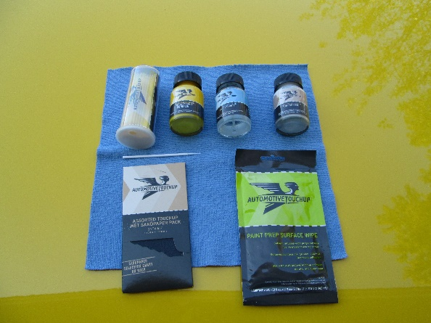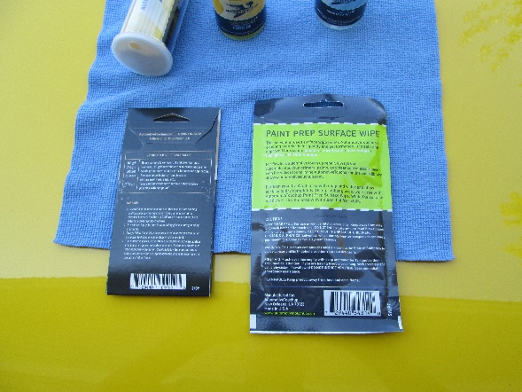
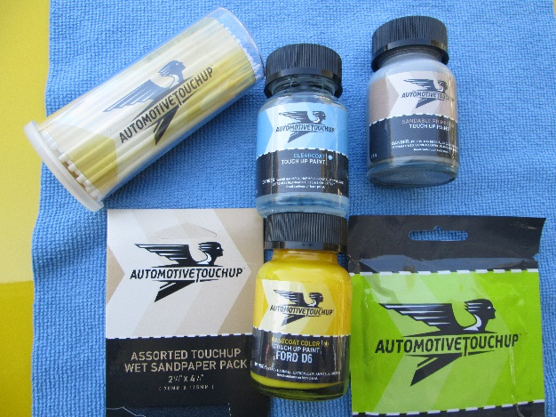

Typical hood paint chip
These were some deep chips on the hood of this Screaming Yellow 2006 Ford Focus. Using AutomotiveTouchup products in a few simples steps save the car from needing paint work in a body shop.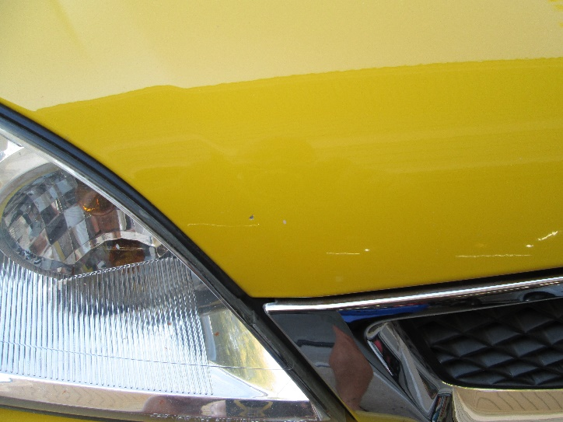 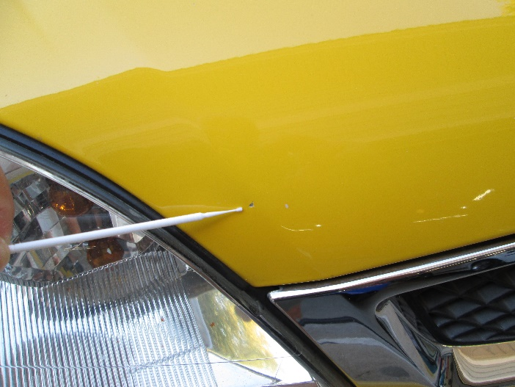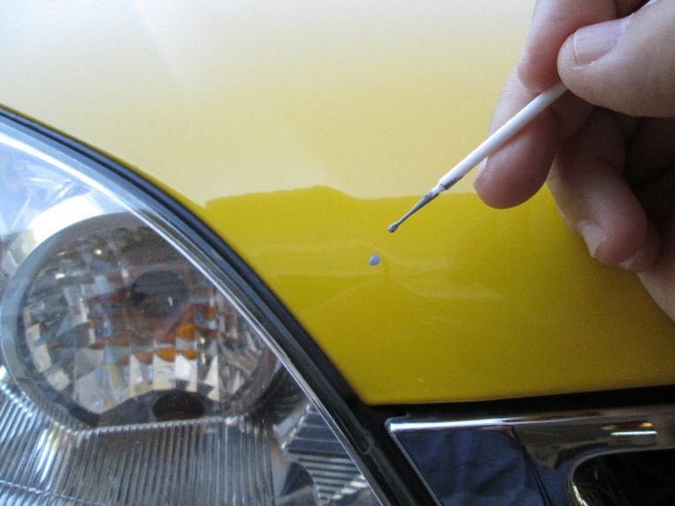 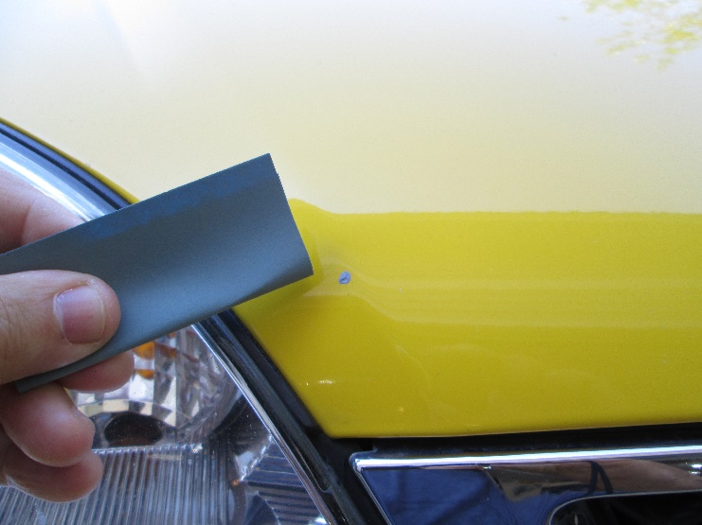 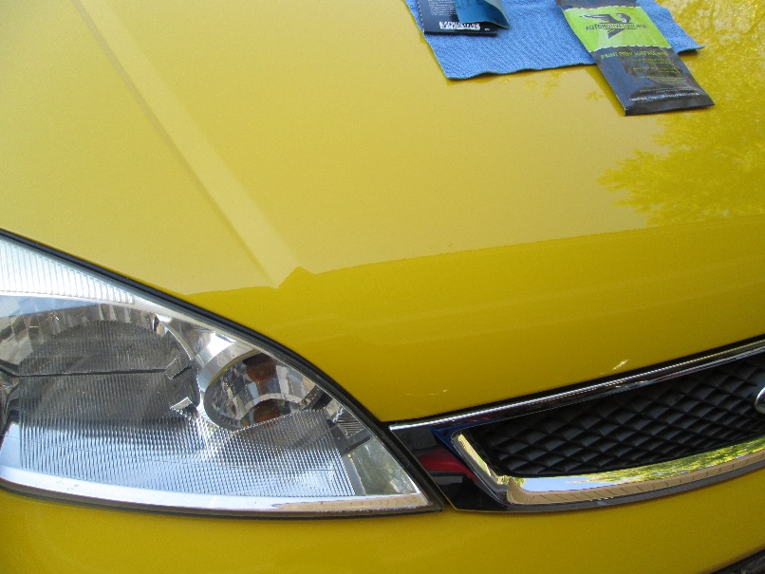

Paint chip on plastic bumper
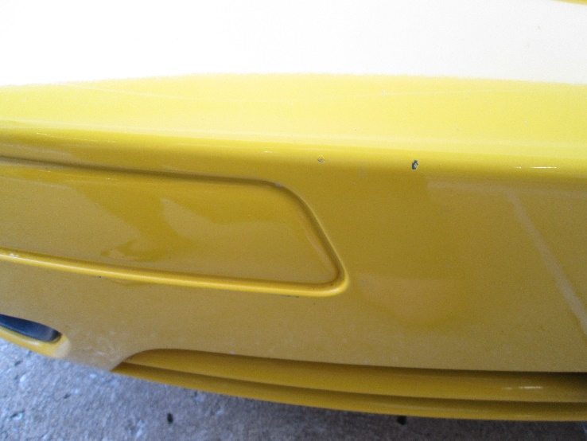 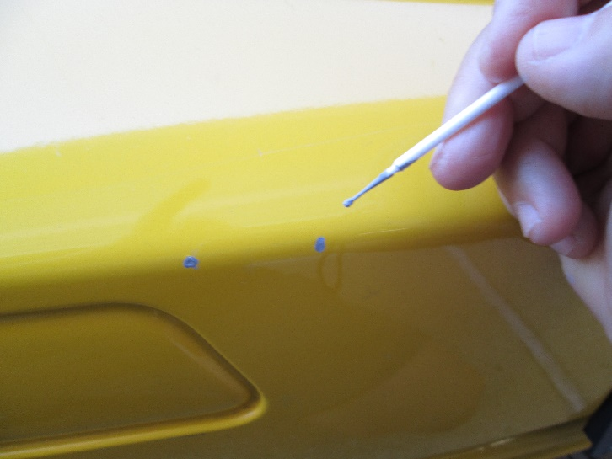 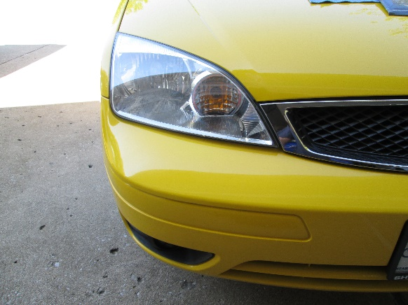 Front End looking great with AutomotiveTouchup! 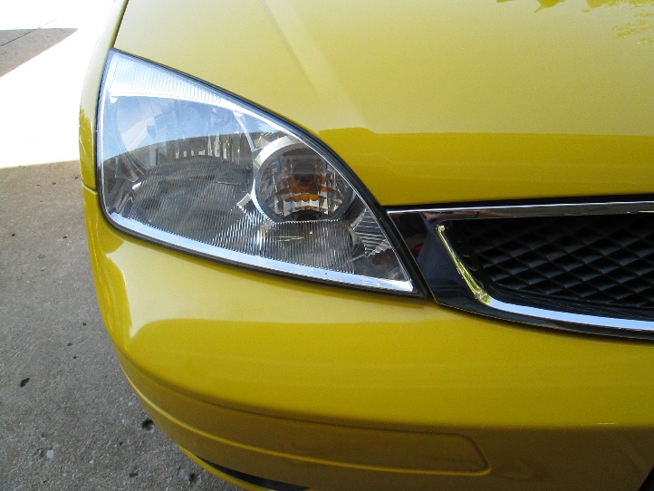

Lots of paint chips on door jam
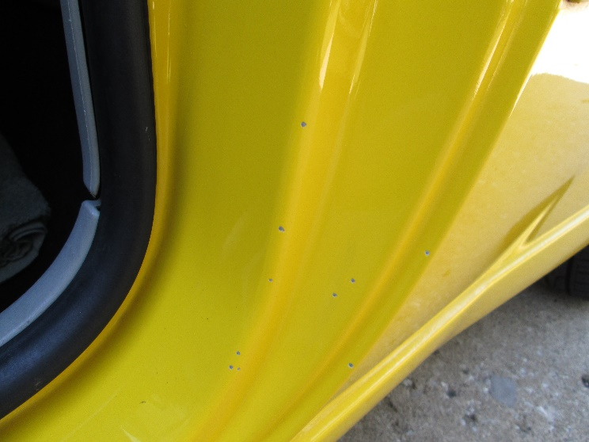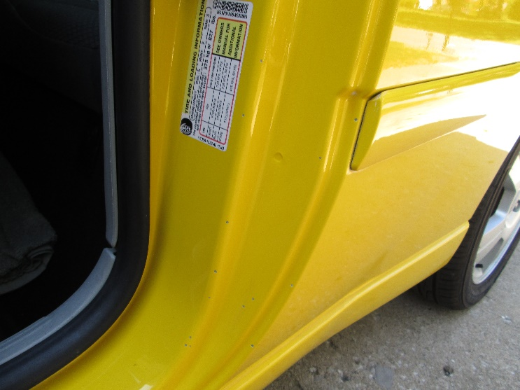 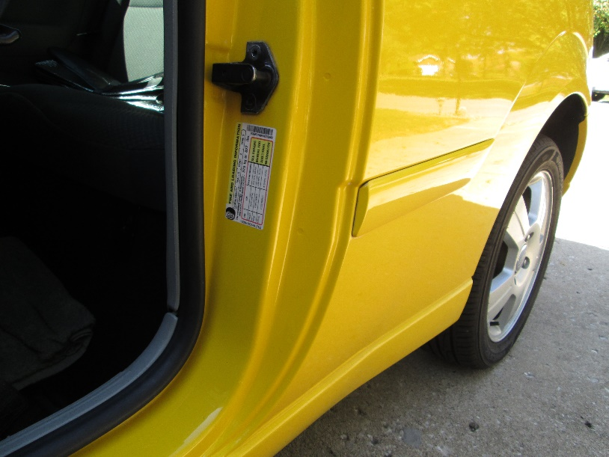Door Jam After

Paint worn off on door molding
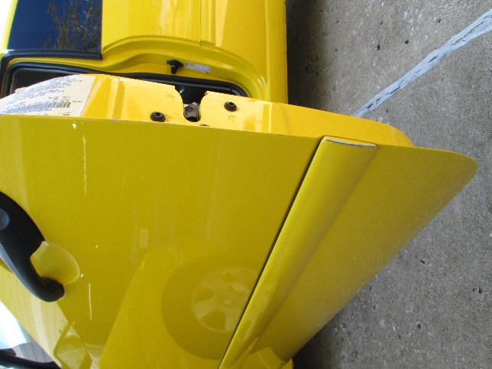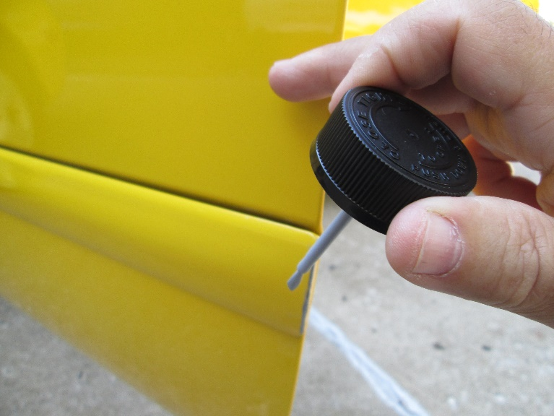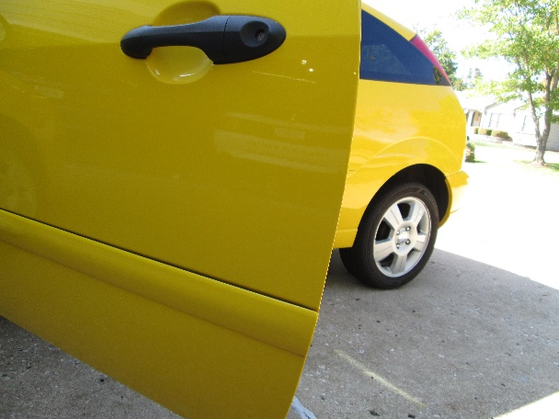

Did you know that these Microdabbers, a favorite tool of mine, have the capability to bend making getting in those hard to reach areas much easier and also offering added control when applying the primer and/or the paint? A must have purchase.
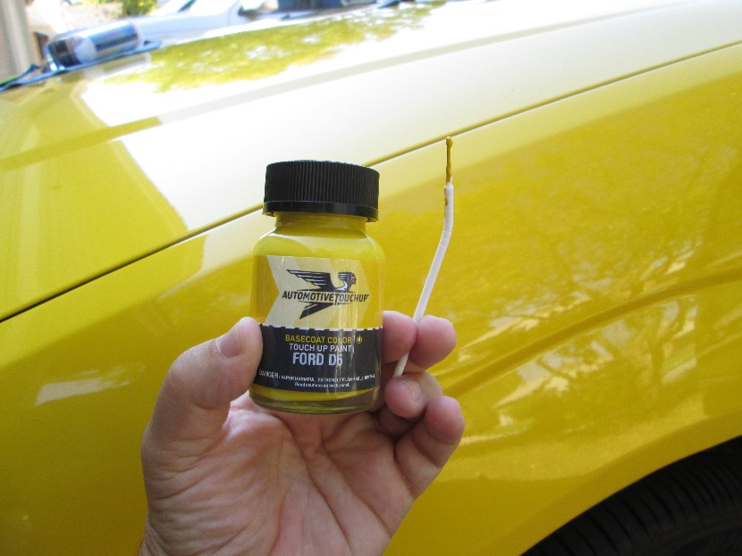
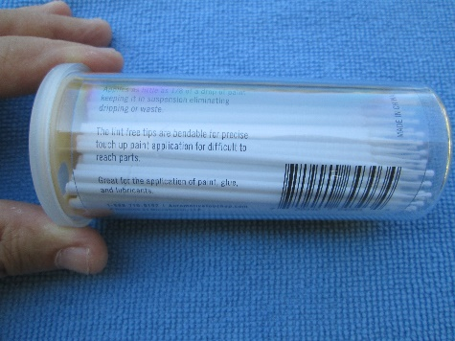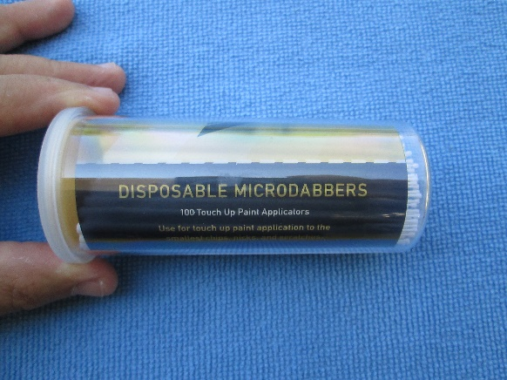
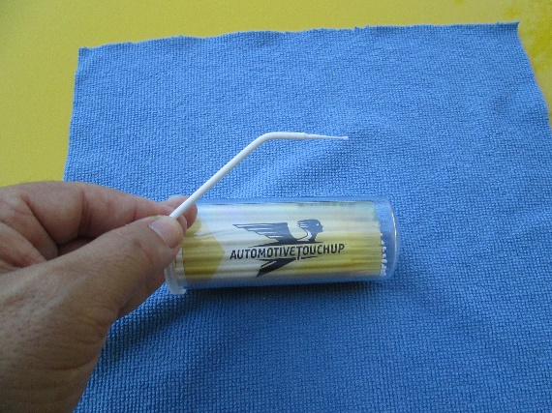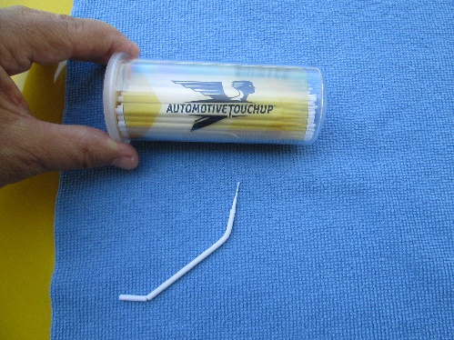 Talk about versatility!

The full line of perfect color matching paint and products from AutomotiveTouchup gives you the tools for simple touchups to repairing areas with a little more paint issues or creating a custom color matched accessory.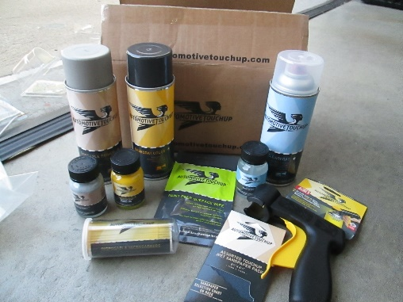 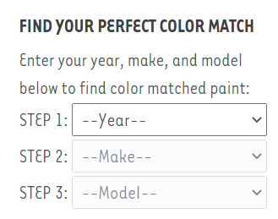
Probably the tool that surprised me the most is their aerosol paint handle. You can find others in hardware stores, but they do not compare to the quality of AutomotiveTouchup. I have used this product for painting patio furniture, and I can tell you on doing bigger projects like that it is my go-to tool.
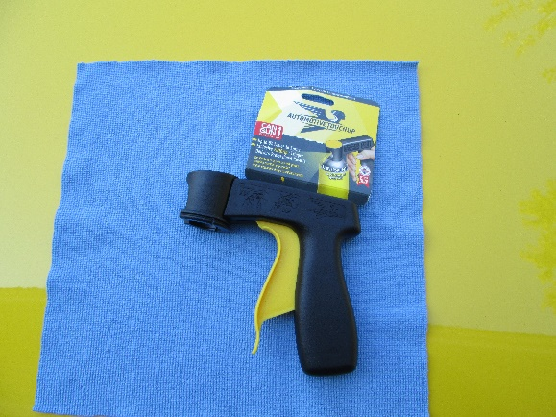

Supply Source:
https://www.automotivetouchup.com/
Toll Free: 1-888-710-5192

Supplies used for paint touch up:
Paint Prep Surface Wipe
Assorted Touchup Wet SandPaper Pack
2 oz jar Sandable Primer (brush in cap) Touch Up paint
2 oz jar Base Coat Color (brush in cap) Touch Up paint
2 oz jar Clear Coat (brush in cap) Touch Up paint
Disposable Microdabbers
Aerosol products & tool also shown

